The details from the motor controller data sheet are:
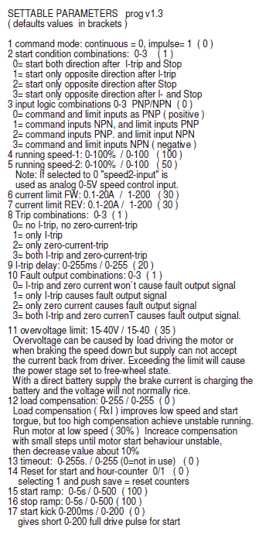

I am changing these to:
- 0 (no change)
- 1 (no change)
- 0 (no change)
- 1 (CHANGED)
- 1 (CHANGED)
- 200 (CHANGED)
- 200 (CHANGED)
- 1 (no change)
- 20 (no change)
- 1 (no change)
- 35 (no change)
- 0 (no change)
- 0 (no change)
- 0 (no change)
- 5 (CHANGED)
- 5 (CHANGED)
- 0 (no change)

These put the unit into a mode where the FWD line is 0 for reverse and 1 for forward and the speed is controlled by the ADC on SPEED-2 line. (parameters 4/5)

Parameters 6/7 set the current limit for overcurrent. This is 200 = 20.0A and is the highest. This might need to be changed in the future.

Parameters 15/16 are changed to 5 to give very fast slow down to stop limits switches being hit too hard.

